Test & Approval
Inputs:
App binaries
How to obtain copy
- Installer msi, zip, web-install
- Dump
- Zip Extracted
Testbed :
Microsoft Windows
Testing Terminal Eskom Prepared
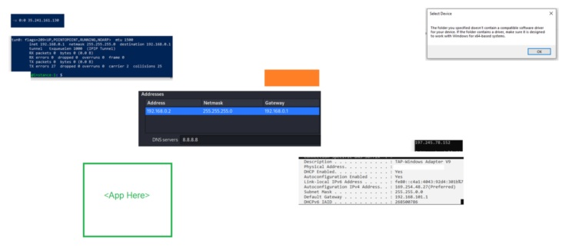

Model, Theory
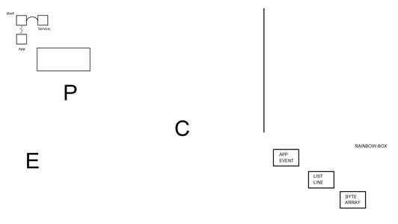
(container framework gateway) EPC, D,R,C
Present, Tool
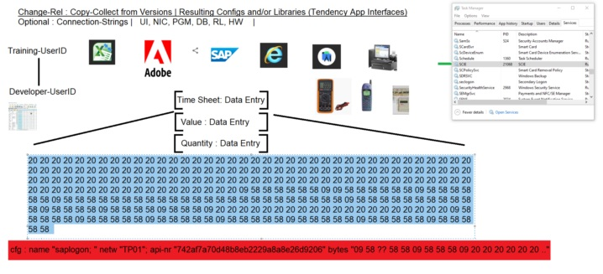

Deliverables :
Byte-Array
- SCIE Service read App-Id and Byte-Array from *.ini file.
List
- Completion run consist of Part-Line[1] and Part-Line[2] thereafter know as Line
Line
- Port-Nat ingress, receive Part-Line[1] to Area ipv4.
- Port-Nat egress, device transmit Part-Line[1] of Device ipv4
- Port-Nat ingress, recieve & reply Part-Line[2] of Device-Host ipv4 (Any Host)
- Port-Nat egress, transmit List[n] to Host ipv4. (Eskom)

Build : Build-Script
Aarch, Lang incremental Versioning
Kernel
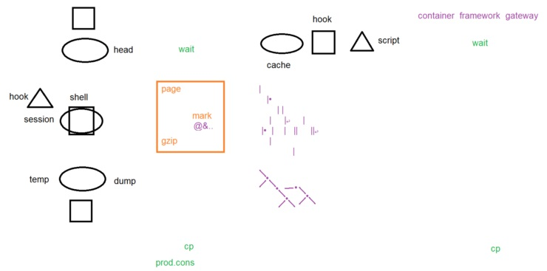

Real, Chain
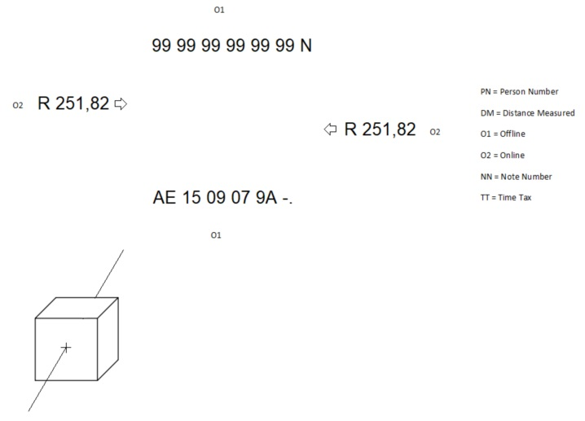
Buffer
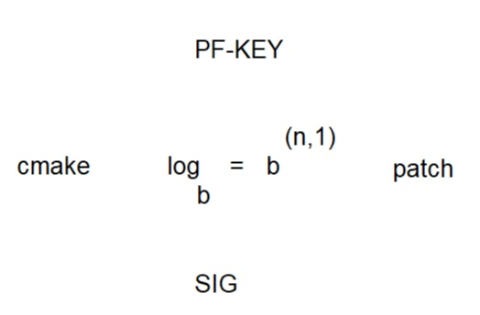
Inter Process Communication
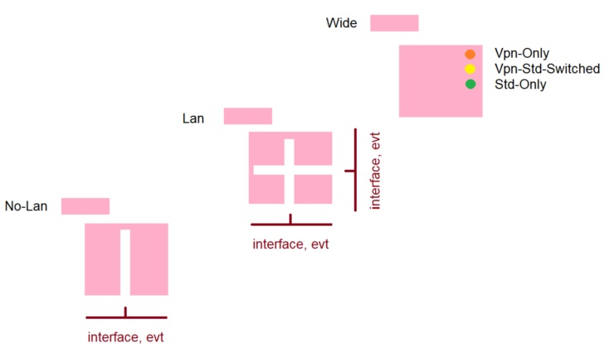

Final Target, Deliverable [Build-N]
SCIE, (Any)
